TH E CE D ARS OF CHAPE L H I LL / M AR CH 2026
THE CEDARS POST
Spotlight on Charles Coble

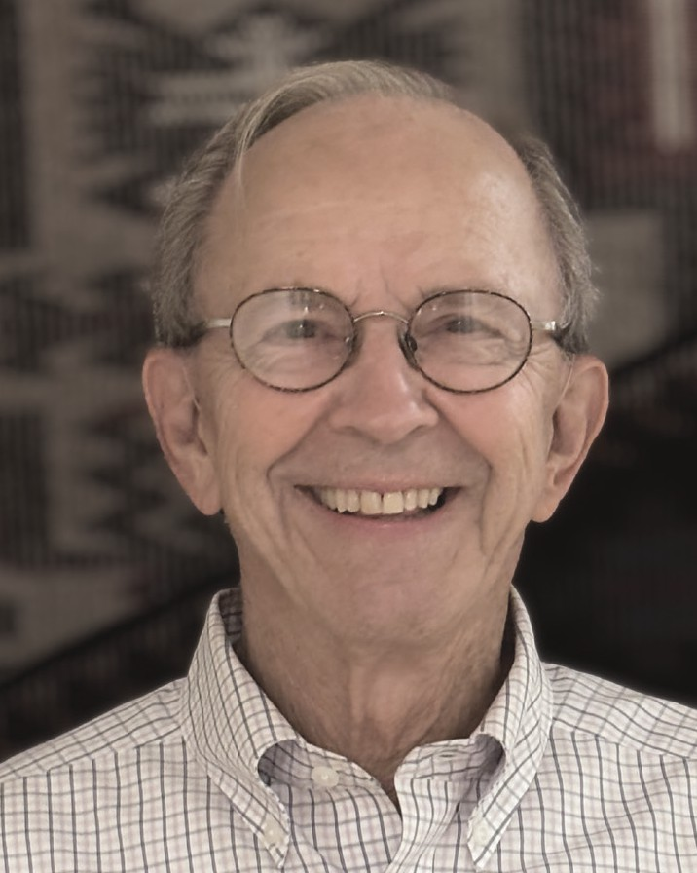
Charles Coble loves science, teaching, and his native state, North Carolina. Over his distinguished career, he has united these passions to transform public education in science in the state, the country, and abroad.
Raised in Oakboro in Stanley County, he majored in science at Mars Hill Junior College and in botany at the University of North Carolina-Chapel Hill. As a graduate student in science education at UNC, he taught biology and physical science at New Hanover High School in Wilmington. In one of his most successful lessons he took his students on a foggy night
to investigate the legend of the Maco light, supposedly the lantern of poor Joe Baldwin, decapitated in an 1867 train accident. Subsequently, Charles taught earth science to middle schoolers in Charlotte-Mecklenburg and became North Carolina’s first public school planetarium teacher and instructional television science coordinator for Charlotte-Mecklenburg.
Early in 1968 Charles’s life took a fateful turn with a stop at a pizza parlor in Greensboro. There he was immediately magnetized by electric Diana Semke, a
MAT student in social science at UNC-CH. Before year’s end, he had pursued her to the altar in Enid, Oklahoma. Their strong attraction resulted in two children, Christopher and Andrea, and four grandchildren.
Charles attained his doctorate in Science Education from UNC in 1971 and joined the faculty at East Carolina University. He quickly rose to Dean of the School of Education and made the school a beehive of industry and innovation, securing a trove of major grants and working closely with public schools to improve teacher preparation. He co-authored two widely adopted science textbooks, co-authored three other books in an integrated science series, and wrote more than eighty specialized articles. One on the importance of teacher certification for mathematics instruction, was hailed
as one of the top articles on teacher preparation of the century. He also published comparative studies of US
and Japanese primary and middle-grade school science students
that exposed significant lags in science thinking, process skills, and achievement in American education.
In recognition of his successes, in 1996 UNC system President C. Dixon Spangler selected Charles as the
first Vice President for University-School Programs. Charles created the pioneering UNC Center for School Leadership Development and worked with Governor James Hunt to make North Carolina a leader in public education.
Charles retired from this position in 2002. That same year he received the Order of the Long Leaf Pine, the state’s highest civilian award.
Yet, far from resting on his laurels, Charles assumed a new role on the national stage. Moving to Denver, Colorado, he joined the Education Commission of the States, becoming Vice President for Policy Studies and Programs. Returning to North Carolina in 2005, he established two notable series of partnerships devoted to improving public education: one The Third Mile Group, an educational and social justice firm; and Teacher Preparation Analytics, devoted to improving teacher and administrative preparation. He also served as co-director of the Science and Mathematics Teacher Imperative for the Association for Public and Land-grant Universities. Thirty-one states and over 130 state research universities became active in this unprecedented effort to improve the number, quantity, and diversity of STEM teachers.
Charles’s dedication to science education has also led him to head research and development grants and contracts in England, Germany, Italy, Japan, and Egypt. Archimedes famously declared, give me a place to stand, and I will move the earth. For Charles, that place is science education in public schools and universities, and the leverage he has achieved is monumental.
by john Kasson
for the Communications Committee

Learning Opportunities

Cedars Lecture Series with Dick Isabel: Kenn Gardner Tuesday, March 3rd, 2pm, The Cedars Room

Discover the remarkable story of Walt Disney from humble beginnings and early failures to building one of the world’s most influential entertainment empires. This engaging lecture explores his creative vision, groundbreaking innovations in animation, and the creation of beloved characters and theme parks. Learn how imagination, perseverance, and bold risk-taking transformed Disney into a global cultural icon.

The Joys of Learning Lecture Series: “Macbeth in Shakespeare’s Time and Ours,” by Mary Floyd-Wilson, Professor of English at UNC
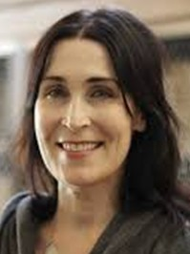
Thursday, March 5th, 2pm, The Cedars Room

Shakespeare’s Macbeth will be performed at UNC’s Playmakers’ Repertory Company from March 4-22. Mary Floyd-Wilson, Mann Distinguished Professor of English and Comparative Literature at UNC, will speak on the play’s enduring fascination with an emphasis on the role of magic and the supernatural in Shakespeare’s time and our own.

Scott Mason: The Tarheel Traveler Tuesday, March 24th, 2pm, The Cedars Room
Join beloved storyteller and broadcaster Scott Mason—

known across North Carolina as “The Tarheel Traveler”—for an engaging lecture filled with heartwarming stories, unforgettable characters, and hidden gems from across the state. With humor and insight, Mason shares behind-the-scenes moments from his travels and celebrates the everyday people and places that make North Carolina unique.

Arts and Culture

International Lunch Bunch: Fonda Lupita- Brightleaf Tuesday, March 10th 11am, Lobby. Transportation Fee $7
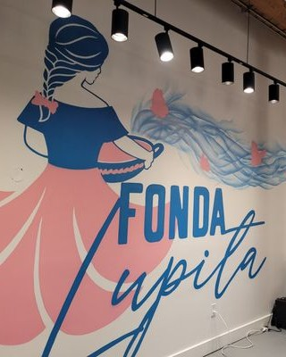
Join us for a delicious lunch at Fonda Lupita, a local favorite known for authentic Mexican flavors and a warm, welcoming atmosphere. Be sure to try their famous gorditas, along with freshly made tacos and house specialties. Their original Sanford location was named one of the best new restaurants in the nation—proof of the quality and care behind every dish. Come enjoy a relaxed afternoon filled with great food and even better company. Registration includes transportation. Please bring cash or card for lunch

Ackland Field Trip: Boys Will Be Men
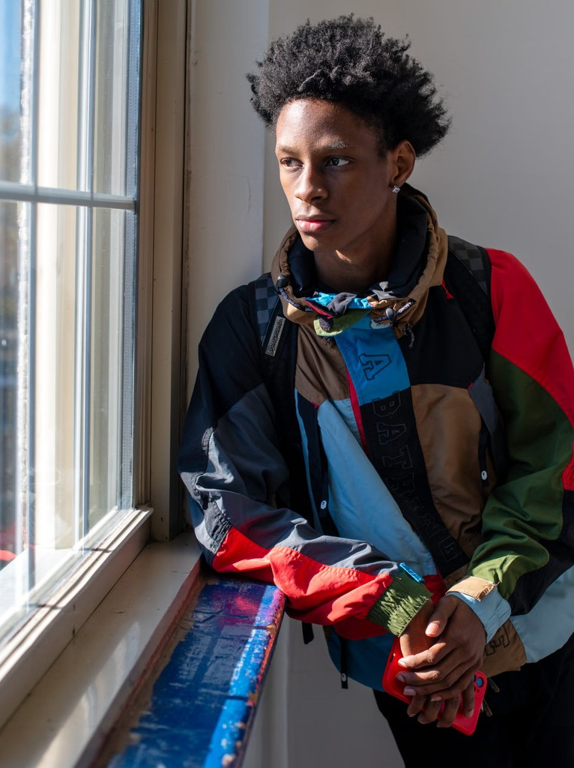
Friday, March 13th 11am, Lobby, Registration $10
Join us for a field trip to the Ackland Art Museum to explore the powerful exhibition Boys Will Be Men, featuring photographs by Durham-based artist Bill Bamberger. This thought-provoking exhibit presents portraits and personal reflections from local high school students, offering insight into the journey from adolescence to adulthood and the many ways young men experience growing up. Registration includes transportation and a docent-led tour.

From Grief to Love: Walking Around England and Wales with Author Laurence Carter
Saturday, March 14th 2pm, The Cedars Room
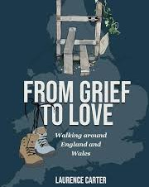
In June 2018 author, Laurence Carter, set off alone on a one-year walk of 4,314 miles around the coast of England and Wales in honor of his late wife to raise awareness of cervical cancer. A stranger told him that the people he met would change him. They did. Their stories enabled him to move beyond grief to love again. Laurence’s book, a moving and often humorous account of his journey, will be available free to
participants. Wine and light refreshments served.

Arts and Culture

Fluid Art Workshop in Two Parts: Florals for Spring on Tile, Glass, and Canvas With Paula Sloan
Tuesday, March 10th & Thursday March 12th 1-4pm, Art Studio. Materials Fee $15
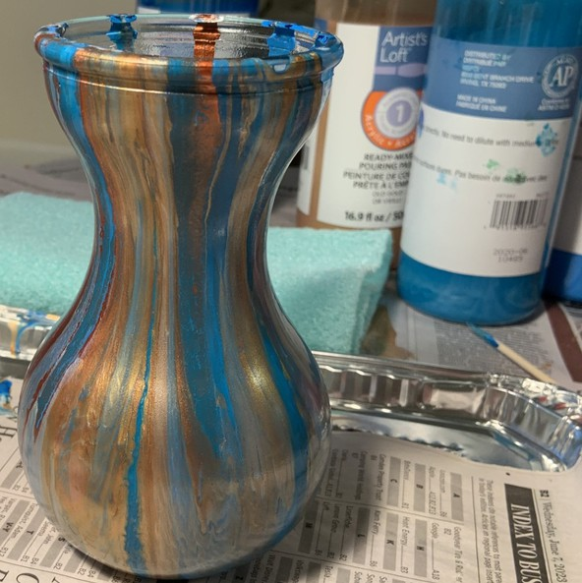
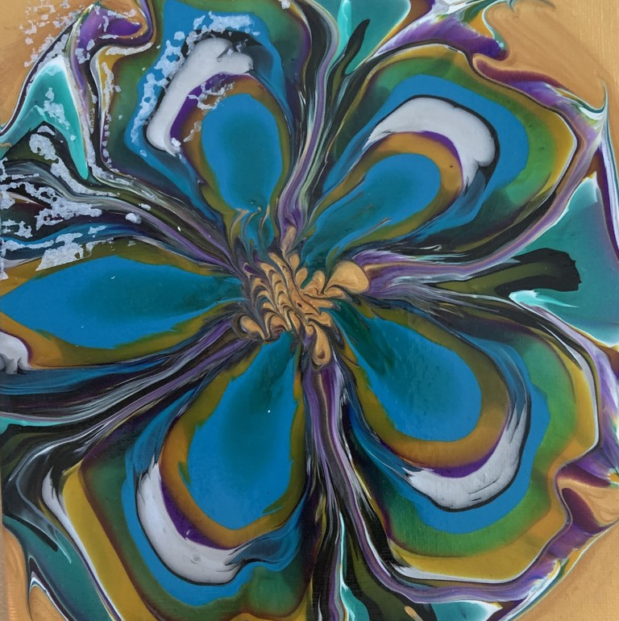
Celebrate spring with a hands-on fluid art workshop where participants will create a vibrant flower design and a beautifully poured flower vase. Using flowing paint techniques, you’ll explore color, movement, and texture to craft two unique seasonal pieces. No experience is needed; just come ready to experiment, have fun, and leave with cheerful artwork perfect for welcoming spring. All materials provided. Fee paid directly to Paula Sloan.

Let’s Talk Cinema with Linda Luftig: NOUVELLE VAGUE (2025) Thursday, March 12th 1pm, The Cedars Room

NOUVELLE VAGUE dramatizes the chaotic making of the 1960 groundbreaking French film BREATHLESS. Let’s Talk Cinema showed BREATHLESS on February 19, and the film is now streaming on Amazon Prime if you’d like to see it before seeing NOUVELLE VAGUE (though it is not necessary to see it first). The style of Linklater’s film is made to look like the film it depicts. It’s a re-creation of a defining moment of film history, and a delight to watch.

Documentary Film Club: The CRISPR Revolution: Hacking the Genetic code Friday, March 20th 1pm, The Cedars Room

CRISPR has opened up a way for scientists to correct genetic mistakes in humans or make modifications to improve plant or animal life. Just like you might edit a document, CRISPR’s power allows you to edit a gene. CRISPR is like your cursor precisely locating the word you want to change. Cas9 is your delete key, cutting out the error. And your cell’s natural DNA repair machinery is the autocorrect, pasting in the new sequence you provide.
This video will help us learn what is happening with the development of these gene editing tools for plants, animals, and eventually humans.

Spring into Spring

Shenanigans with the O'Florapist Flower Arrangement Workshop Tuesday, March 17th 11am, The Art Studio, Registration $25

Discover the art of floral design in this hands-on flower arrangement workshop. Learn how to select blooms, balance color and texture, and create a beautifully composed arrangement to take home. Whether you’re a beginner or simply looking to refresh your skills, this welcoming class offers step-by-step guidance, creative inspiration, and a relaxing way to celebrate the beauty of the season.

Spring Food Drive Benefiting PORCH of Chapel Hill Thursday, March 19th- Thursday, March 26th, Lower Lobby

Support our neighbors in need by contributing to our upcoming food drive benefiting PORCH Chapel Hill-Carrboro. PORCH (People Offering Relief for Chapel Hill–Carrboro) is a local nonprofit that collects and distributes food to individuals and families facing food insecurity in our community. Most-needed items include canned vegetables and fruits, rice, pasta, beans, peanut butter, cereal, and other nonperishable staples. Every donation helps provide nutritious meals and meaningful support.



Classical Concert Music Festival
This year’s March Classical Concert Festival grew out of an unusual set of circumstances. With two outstanding concerts already scheduled for March, the cancellation of the North Carolina Baroque Orchestra Chamber Players' performance on January 31 due to inclement weather created an unexpected opening. When Heartland Baroque became available on March 20, the opportunity arose to bring all three performances together as a month-long celebration.

The Signum Quartet
Sunday, March 1st 3pm, The Cedars Room
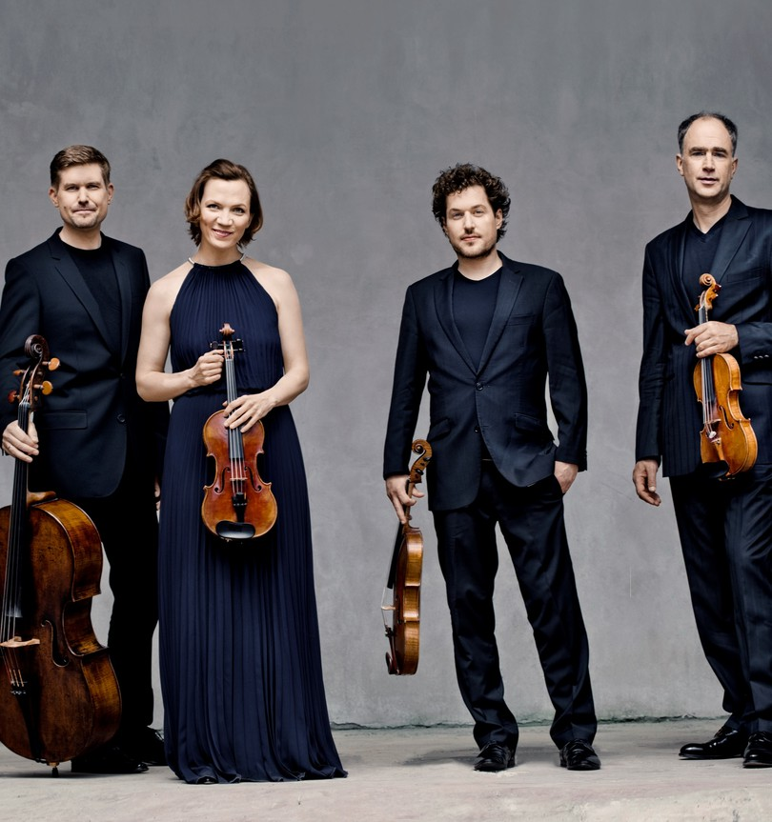
The internationally acclaimed Signum Quartet, founded in Germany in 1994, brings its distinctive artistry to The Cedars. Their playing is marked by warmth, precision, and a strong sense of ensemble; qualities that make their concerts both intellectually engaging and deeply rewarding for audiences.
The members of the Signum Quartet are Florian Donderer and Annette Walther, violins; Xandi van Dijk, viola; and Thomas Schmitz, violoncello.

Heartland Baroque
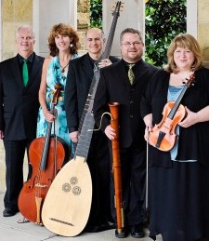
Friday, March 20th 7pm, The Cedars Room
Heartland Baroque, based in Bloomington, IN, is known for its engaging storytelling and historically informed performances played on period instruments. The ensemble immerses its audiences in the Baroque era. The members of Heartland Baroque are Martie Perry and David Wilson, baroque violins; Barbara Krumdieck, baroque cello; Keith Colling, dulcian and baroque bassoon; William Simms, theorbo and baroque guitar; and guest artist Charles Humphries, countertenor.
This concert replaces the NC Baroque Orchestra Chamber Players performance, which was canceled due to weather.

The Shelests (One Piano, Four Hands) Sunday, March 29th 3pm, The Cedars Room
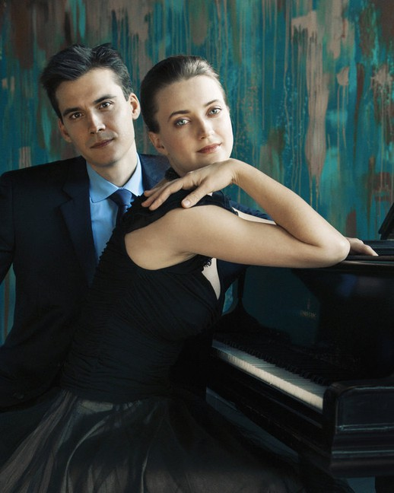
The Shelests are an acclaimed husband-and-wife piano duo known for their electrifying four-hand performances and deeply expressive musicianship. Ukrainian-born pianists Dmitri and Anna Shelest transform a single piano into a richly colored and orchestral sound world. Their concerts are marked by passion, passion, and a strong sense of connection with audiences.
For subscribers only. For questions: Nancy Buell • 617-699-6193 • nhbuell@gmail.com

Full Body Wellness

Nutrition Lecture: Med-South with Dr. Alice Ammerman, DrPH and Dr. Thomas Keyserling, MD, MPH
Thursday, March 26th 11am, The Cedars Room

Join us for an engaging lecture on the Med-South diet; a Mediterranean-style approach adapted for the Southeastern U.S. Learn how this innovative, research-based plan supports heart health and chronic disease prevention while reflecting local food traditions, sustainability, and improved access to nutritious, affordable meals in our communities.
Heart2HeartNC: A Gentle Hour of Music, Breath & Reflection Friday, March 27th 2pm, The Cedars Room

Join soul singers from Heart2HeartNC for a restorative hour of music, breathwork, and meditation. Since 2018, heart2heartNC has supported individuals navigating end of life and families walking the grief journey, grounded in the power of human connection. Through soothing harmonies, mindful breathing, and gentle sound practices, participants are invited to relax, reflect, and experience a shared sense of healing and peace.

Dix Park Picnic and Guided Troll Art Walk with Michele Wednesday, April 1st, 11 am, Lobby $ 14

Join Michele for a beautiful day in the park. Enjoy a picnic lunch before setting off on an adventure through the grounds to find the Thomas Dambo wooden troll sculptures. Thomas Dambo is a Danish recycled art activist who creates massive, whimsical troll sculptures from salvaged wood and waste materials, often with volunteer help. His mission is to promote sustainability with over 100+ installations worldwide. Lunch and transportation are included. Paths are ADA compliant, but may be challenging for participants with mobility devices. For planning purposes, this event will follow the March Registration Cycle.

Special Events Schedule

Sunday March 1
3pm Classical Concert, TCR

Tuesday, March 3
2pm CLS-Disney, TCR

Wednesday, March 4 6:30pm Duke Symphony Orchestra, Lobby
Thursday, March 5
2pm Joys of Learning TCR 6:30pm NC Symphony, Lobby

Sunday, March 8 6pm Duke Chamber Transportation Lobby
Tuesday, March 10 11am International Lunch Bunch, Lobby
1pm Fluid Art WS, AS

Thursday, March 12
1pm Let’s Talk Cinema, TCR 1pm Fluid Art WS, AS
Friday, March 13
11am Ackland Field Trip, Lobby

Sunday March 15
1:30 Playmakers Transportation, Lobby
Monday, March 16
2pm Grief Group CL

Thursday, March 19 2:45pm Art in Bloom, Lobby PORCH Food Drive Starts
Friday , March 20
1pm Documentary Film Club TRC
7pm Classical Concert, TCR

Saturday, March 21
1pm Carolina Ballet, Lobby
Monday , March 23 3:30pm Finishing Touches 4pm Death Café, TCR

Tuesday, March 24 2pm Scott Mason, The Tarheel Traveler, TCR
Thursday, March 26
11am Med-South TCR
2pm Members Meeting TCR
Friday, March 27
2pm Heart2HeartNC, TCR 6:30pm Duke Chamber Arts, Lobby

Sunday, March 29
3pm Classical Concert, TCR

Group Contacts
Bocce
Barbara Putney

Chess Club Carol Downs

Cribbage Malcolm Jackson

Duplicate Bridge Jo Hazzard

Early Birds Margaret Rook

Golf Croquet Bill Kirwan

Knit and Stitch Margaret Rook

Mah Jongg Barbara Kemper

Memoir Writing Group Nancy Lebo

Mexican Train Dominoes Mary Ann Van Kampen

Modern American Canasta Bonnie Farb

Open Door Bible Study Nancy Cobey

Ping Pong Pat Kelley

Play Reading Group Bill Gibson




Registration Required Off-Campus

Signed up for a trip?
Make it to the bus on time. Please call the Concierge at 919-259-7937 if you registered and are unable to attend.
Poker
Richard Orcutt

Pole Walking Joan Onjes

Samba Jesse Ogburn

Sunday Chapel Church Nancy Cobey

Recurring Weekly Schedule
Monday
9am Ping Pong TCR 9am Aquafit P
9:45am Aqua Walking P 10am Balance 101 TCR 10:30 Balance 102 TRC 10:30am Knit & Stitch CL
12:30pm Play Reading Group Z 1pm Poker CR
2pm Chess Club CR
2pm Mexican Train Dominos CR
Tuesday
8:30am Total Body Strength & Stretch TCR
9:30am Sit & Be Fit TCR
10:45 Pilates with Brianna TCR 1pm Samba CR
1pm Golf Croquet GL 1pm Mah Jongg CV4
1pm Supervised Gym Touchpoints
Wednesday
8:15am Circuit Work TCR 9am Aquafit P
9am Ping Pong TCR
10am Open Door Bible Group Z 10am Mat Yoga TCR
11:15am Chair Yoga TCR 1pm Bocce GL
1pm Duplicate Bridge TCR 1pm Party Bridge CR 1:30pm Mah Jongg CR
Thursday
8:30 Cardio Combo TCR
9:30am Sit and Be Fit TCR 11am Cedars University TCR 1pm Golf Croquet GL
1pm Supervised Gym Touchpoints 1:30pm Modern American Canasta CR 3pm Scrabble CR
Friday
8am Early Birds TCR
9am Aquafit P
10am Balance 101 TCR 10:30am Balance 102 TCR 11am Barre with Brianna TCR 1:30pm Men’s Bridge Group CR 1:30pm Samba CR
Saturday
8am Early Birds TCR 9am Ping Pong TCR 10am Cribbage CL
1:30pm Modern American Canasta CR
Sunday
11am Sunday Chapel Church, TCR 4pm Mindful Moves with Joanne, TRC (No Class 3/1 or 3/29)
Exceptions
Check the Portal for Tech Support Dates and the Most Current Changes

P-Pool TCR-Cedars Room CL- Classroom CR-Cardroom GL Great Lawn LB-Lobby Z-Zoom

Announcements

Voting Transportation, Tuesday, March 3rd. Buses leave at 9 am, 11 am, 1 pm, and 3 pm. Contact Transportation to schedule a time.

Jewelry repair with Eva Mogenson Friday, March 6th, 2pm Art Studio

Shabbat Service led by Connie Margolin Friday, March 13th, 4pm (2nd Fridays) DuBose Conference Room

Sunday Chapel Church Sundays The Cedars Room. All are welcome
Great Short Stories Series Contact Bill Buxton bill.buxton@vistagechair.com Mar 9: The Things They Carried by Tim O’Brien
Mar 23: TBD
10 am Classroom

CEDARS PORCH COLLECTION
Monday, March 9, 8:30 am Food should be out for pickup by 8:30am on Front Porches or Veranda Parking Lot Bench, or you can leave a check anytime with the Clubhouse Concierge.
Questions: Contact Joy Metelits at (919) 933-0724
Joymetelits@gmail.com
2026 dates: March 9, April 13,
May 4, June 8, July 13, Aug 10,
Sept 14, Oct 5, Nov 2, Dec 7






March Birthdays

Donald Dillport | 3-Mar | Myron Liptzin | 17-Mar
Gerald Guyer | 3-Mar | Eileen Preiss | 18-Mar
Lucjan Mordzak | 4-Mar | Eleanor Lamb | 20-Mar
Brent Elmore | 5-Mar | Rachel Willis | 20-Mar
Judy Davidson | 6-Mar | Uliana Gabara | 23-Mar
Joy Douglass | 8-Mar | Barbara McLean | 24-Mar
James Putney | 8-Mar | Susan Williams | 24-Mar
Jon Kates | 9-Mar | Peter Page | 25-Mar
Holly Wilson | 9-Mar | Bette Israel | 26-Mar
Susan Nelson | 11-Mar | James Fountain | 27-Mar
Sue Greenberg | 14-Mar | Jim Mullen | 27-Mar
Paula Newton | 14-Mar | Debbie Winfield | 28-Mar
Ann Christy | 15-Mar | Charles Hochman | 29-Mar
Bob Farb | 16-Mar | Bob Rechholtz | 29-Mar

Fitness Happenings

March Into Mindfulness

March is a natural invitation to reset. As the seasons begin to shift, we are reminded that renewal does not always require big changes; sometimes it begins with simply slowing down. Mindfulness is more than meditation. It is the practice of being present in your body, aware of your breath, and connected to the moment you are in. Research continues to show that gentle breathing practices, reflective pauses, and calming music can help regulate the nervous system, lower stress hormones, improve sleep, and support overall emotional well-being.
The Cedars Club, Inc. 100
Cedar Club Circle, Chapel Hill NC 27517
In-House TV Channel 1340
Cedars Live TV Channel 1341
Reception 919-259-7000
Concierge 919-259-7937
Fax 919-259-7001 Spa & Salon 919-259-7940 Dining 919-259-7932 Work Orders 919-259-7918
Security 919-883-7666
Transportation 919-259-7740

Movement plays an equally important role. Whether it is a short walk, light stretching, or simply adjusting posture and breathing with awareness, small intentional actions help maintain circulation, balance, and cognitive clarity. When we combine breath, music, and mindful presence, the body often softens, the mind settles, and a sense of connection returns.
To support this theme of mindfulness and renewal, we invite you to join us for a special community gathering join us for “heart2heartnc presents, A Gentle Hour of Music, Breath & Reflection,” on March 27th at 2:00 PM, Cedars Room. This calming experience will include live instrumental music, brief guided meditation, and gentle breathwork woven throughout the hour. The intention is simple: to create a peaceful space for reflection, relaxation, and connection.

This offering is part of Heart to Heart’s broader support for grief, life transitions, and times of loss, with gentle emotional and end-of-life support available for those who may benefit

Looking Ahead to April

Troll Walk at Dix Park April 1st at 11 AM
Join us for a refreshing spring stroll as we visit the artful Troll installations at Dix Park. We will enjoy a relaxed walk, take in the scenery, and gather for lunch together. It’s a wonderful opportunity to move your body, enjoy fresh air, and connect with friends

