TH E CE D ARS OF CHAPE L H I LL / j A nu AR y 2026
THE CEDARS POST
Spotlight on Joseph S Pagano

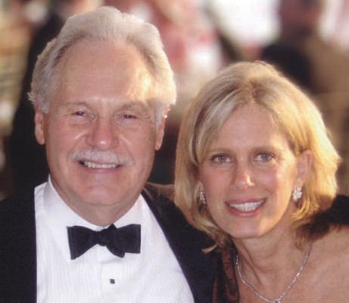
Joe Pagano is a pioneering virologist, nationally recognized cancer center researcher and the founding director emeritus of UNC’s Lineberger Comprehensive Cancer Center. He joined the UNC faculty in 1965 and led the creation of the cancer center in 1975, serving as its director until 1997. Under his leadership the center grew into one of North Carolina’s
foremost research institutions;
today the UNC Lineberger is an NCI-designated comprehensive cancer center rated “exceptional” by the National Cancer Institute. Colleagues praise Dr Pagano for his visionary leadership and “magnetic intellect,” noting that his vision “set the stage” for the center’s culture and success.
Born in 1931 in Rochester NY to Sicilian immigrants, Joe was a voracious reader in his youth and spent hours in the library. He decided at the age of six that he wanted to be doctor and stuck to that. He received an AB in English from the University of Rochester in 1953, and an MD from Yale University in 1957. He worked at Massachusetts Memorial
and Peter Bent Brigham hospitals in Boston, and at the Karolinska Instituted in Sweden in the 1960s. He joined the Wistar Institute as a researcher and taught at the University of Pennsylvania. Then in 1965, he joined the Department of Bacteriology and Immunology at UNC-CH, and subsequently chaired the Department of Infectious Diseases.
Joe was one of the first scientists to link Epstein-Barr virus (EBV) to human cancers. In landmark studies he showed that EBV DNA is present not
only in African Burkitt’s lymphoma but also in nasopharyngeal carcinoma—a common cancer in southern China. This work established that a single virus could underlie multiple distinct tumor types. In later work he studied how EBV persists in infected cells and drives tumor growth and he led extensive antiviral
drug research to inhibit EBV replication and transformation. He also studied how EBV can cause B-cell lymphomas in immunosuppressed organ transplant recipients, and how drugs can inhibit the growth of lymphomas.
Joe’s contributions have earned many honors. He was elected to the National
Academy of Medicine in 1998 and received North Carolina’s highest civilian honor—the
North Carolina Award in Science—in 1996. In 2012 he won the Battle Distinguished Cancer Research Award at UNC. In recognition of his legacy, UNC Lineberger annually presents the Joseph S Pagano Award to an outstanding postdoctoral fellow, and a conference room at UNC carries his name.
Beyond the lab, Joe is known as a dedicated mentor and community figure. He has lectured around
the world and was an active member of the Chapel Hill community. Even past age 80 he was noted as a dedicated squash and tennis player and a proud
grandfather. Joe and Jody (Friedberg) Pagano were married in 2008, and because of their combined families they have 4 children and 9 grandchildren. Joe and Jody moved to the Cedars in 2018. Jody reminisces that Joe was a lover of art, music, literature, a world traveler. He also loved to feed birds and garden (particularly to prune plants), and Joe had a habit of going to five different groceries every weekend to select food and drink!
He and Jody have been generous supporters of UNC. Jody recently established the Joseph S Pagano, MD, Distinguished Professorship in Cancer Research, which will be awarded to a UNC Lineberger faculty member conducting life-saving cancer research. Clearly Joe’s lifelong work and leadership have left a lasting imprint on cancer research at UNC and beyond.
by Judith bond bradley
for the Communications Committee

Learning Opportunities

Nutrition and You in the New Year with Michele Baker Monday, January 5th 2pm, The Cedars Room

This interactive nutrition workshop explores practical, science-based strategies for eating well and supporting long-term health. Information has been curated by NIFS specifically for Seniors and their unique needs.
Participants will learn how to make informed food choices, build balanced meals, and develop sustainable habits that fit real life. The session includes discussion, simple tips you can use right away, and time for questions.

Joys of Learning Series: Bible Belt Blues by Hal Crowther Thursday, January 8th 2pm, The Cedars Room
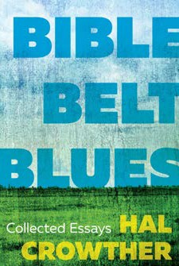
Hal Crowther, nationally acclaimed journalist and cultural commentator, will read from and discuss his new book, Bible Belt Blues, a trenchant critique of life in the South in the twenty-first century. A prize-winning essayist who has been compared to Mark Twain and H.L. Mencken, Crowther will be introduced by his wife, novelist Lee Smith. Some views expressed might be considered divisive. This is a member-sponsored activity and does not express the views of The Cedars. Discretion is advised
Copies of the book will be available for purchase.

Cedars Lecture Series with Dick Isabel: Elisabetta Politi Friday, January 9th 2pm, The Cedars Room
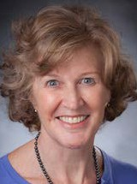
Elisabetta Politi, RD, is a clinical dietitian at Duke University’s Lifestyle & Weight Management Center with over 30 years of experience. She is a certified Diabetes Care and Education Specialist and Health and Wellness Coach. Her career focuses on preventing chronic disease through nutrition, education, and cooking demonstrations. She has been featured in major national and local media and has worked with The Forest at Duke and Carolina Meadows.

New and Exciting
Ceramics Workshop
Thursdays, Jan 8, Jan 15, Jan 22. 2-4pm, Art Studio, Registration $95
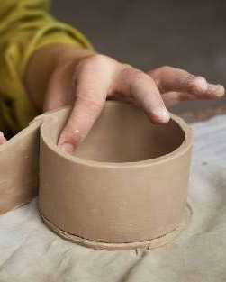
Explore clay slab techniques in this hands-on workshop as you create segmented trays for condiments, chips and dips, or desk organization. Learn to roll and prepare slabs, use molds, add texture and design, finish edges, and create feet or foot rings. You’ll also glaze your piece to make a unique, functional item for your home.
Instructor Frumet of LateBloomerPottery has worked with clay for 25 years, creating functional pottery through wheel throwing and handbuilding.

Grief Group With Helen Svoboda-Barber Monday, January 19th 2pm, The Classroom
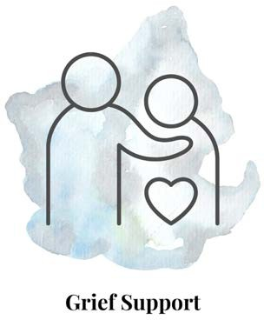
This grief support group offers a compassionate space to share, listen, and heal alongside others who understand the experience of loss. Through guided conversation and mutual support, participants can explore their grief at their own pace, find comfort in community, and discover tools for coping, remembrance, and resilience. All are welcome, wherever they are in their journey. This group will be a monthly offering moving forward.

International Lunch Group: Rasa Malaysia
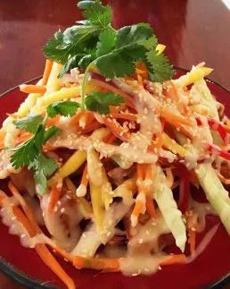
Friday, January 30th 11am, The Cedars Room, Registration $4

Join us for lunch at Rasa Malaysia in Chapel Hill, where bold Malaysian flavors meet warm hospitality. Enjoy freshly prepared dishes inspired by street food favorites, from savory curries to fragrant noodles, all crafted with care and tradition. Come for good food, great company, and a relaxed midday break full of flavor.

On The Big Screen

Let’s Talk Cinema with Linda Luftig: Train Dreams (2025) Thursday January 15 1pm, The Cedars Room

The story of one man’s life lived quietly amidst the forests and railroads of early 20th-century America in the Pacific Northwest - a world changing rapidly around one man’s simple but deeply felt existence. “An astonishingly beautiful film … almost too achingly stunning to be real.” (New York Times). It will break your heart. 102 minutes
Based on the novella by Denis Johnson Discussion led by Linda Luftig

King In the Wilderness
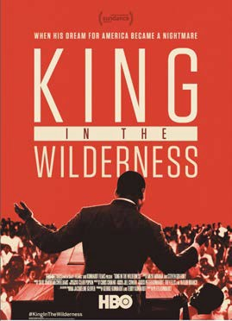
Monday January 19th 1pm, The Cedars Room

King in the Wilderness is a powerful documentary that explores the final years of Dr. Martin Luther King Jr.’s life. Through rare footage and firsthand accounts, the film reveals his evolving vision, personal struggles, and unwavering commitment to justice as he faced increasing opposition while fighting for civil rights, economic equality, and peace.

Documentary Film Club: The Automat Friday, January 23 1pm, The Cedars Room

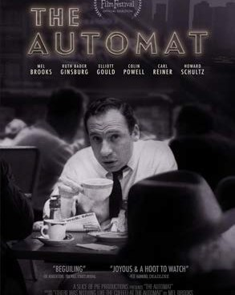
Our January documentary, The Automat, evokes warm memories of New York City and Philadelphia. With nickels in hand, diners chose comfort foods and were served by the iconic coffee “monster.” Learn how this unique restaurant brought people together across all walks of life, with memories shared by Mel Brooks, Colin Powell, Ruth Bader Ginsburg, and Carl Reiner.

Enjoying the Arts

The Harvard Krokodiloes Live
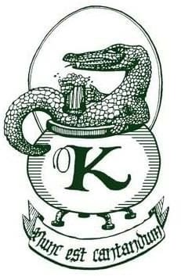
Monday, January 5th 7pm, The Cedars Room
The Harvard Krokodiloes, Harvard’s oldest a cappella group, are known for polished harmonies, humor, and red-sock tuxedos. Founded in 1946, they perform classic and contemporary songs worldwide. Look for Alex and Andy Lim
—brothers of Cedars tech prodigy Holden Lim.

Nasher Art Museum: Everything Now All at Once Friday, January 16th 9:45am, Lobby
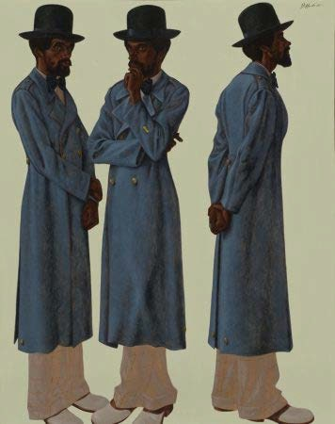
Everything Now All At Once celebrates iconic works from the Nasher Museum’s contemporary collection in honor of its twentieth anniversary. Building a collection is like making a mixtape—carefully curated for meaning, flow, and emotional impact. This exhibition presents the Nasher’s holdings as a visual soundtrack, reflecting shared histories and experiences shaped with audiences at Duke, in Durham, and around the world. Registration includes transportation and a docent-led tour.

Classical Concert Series: NC Baroque Orchestra Saturday, January 31 3pm, The Cedars Room
The North Carolina Baroque Orchestra Chamber Players, a smaller ensemble within NCBO, bring historically informed performances to life with music of the 17th and 18th centuries. Founded in 2011 and based in Davidson, NC, eight musicians will perform Embracing Winter, featuring Bach’s Brandenburg Concerto No. 5. For subscribers only. Info: Nancy Buell, 617-699-6193, nhbuell@gmail.com.
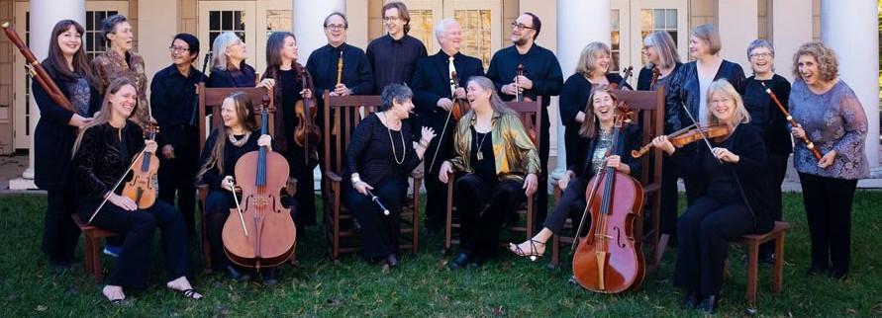

Special Events Schedule

Monday, January 5 2pm, Nutrition and You in the New Year, TCR
Thursday , January 8 2pm Joys of Learning: Bible Belt Blues with Hal Crowder
2pm Ceramics Workshop Starts, AS
Friday , January 9
2pm Cedars Lecture Series With Dick Isabel: Elisabetta Politi
Thursday, January 15 1pm Lets Talk Cinema Train Dreams
Friday, January 16 10 am Nasher Art Museum, Lobby
Monday, January 19 1pm King in The Wilderness, TCR 2pm Grief Group CL

Friday, January 23
1pm Documentry Film Club: The Automat TCR
6:30pm Duke Chamber
Saturday , January 24 7:30pm Carolina Performing Arts, Lobby
Sunday, January 25
2pm NC Symphony, Lobby
Monday , January 26 3:30pm Finishing Touches: Lifestyle Films
4pm Death Cafe
Thursday, January 29 2pm Members Meeting, TCR
Friday, January 30
11am International Food Club: Rasa Malaysia, Lobby

Saturday, January 31 3pm Classical Concert Series: NC Baroque Orchestra, TCR
Group Contacts
Bocce
Barbara Putney

Chess Club Carol Downs

Cribbage Malcolm Jackson

Duplicate Bridge Jo Hazzard

Early Birds Margaret Rook

Golf Croquet Bill Kirwan

Knit and Stitch Margaret Rook

Mah Jongg Barbara Kemper

Memoir Writing Group Nancy Lebo

Mexican Train Dominoes Mary Ann Van Kampen

Modern American Canasta Bonnie Farb

Open Door Bible Study Nancy Cobey

Ping Pong Pat Kelley

Play Reading Group Bill Gibson





Registration Required Off-Campus

Signed up for a trip?
Make it to the bus on time. Please call the Concierge at 919-259-7937 if you registered and are unable to attend.
Poker
Richard Orcutt

Pole Walking Joan Onjes

Samba Jesse Ogburn

Sunday Chapel Church Nancy Cobey

Tuesday
8:30am Total Body Strength & Stretch TCR
9:30am Sit & Be Fit TCR
10:45 Pilates with Brianna TCR 1pm Samba CR
1pm Golf Croquet GL 1pm Mah Jongg CV4
1pm Supervised Gym Touchpoints
Recurring Weekly Schedule
Monday
9am Ping Pong TCR 9am Aquafit P
9:45am Aqua Walking P 10am Balance 101 TCR 10:30 Balance 102 TRC 10:30am Knit & Stitch CL
12:30pm Play Reading Group Z 1pm Poker CR
2pm Chess Club CR
2pm Mexican Train Dominos CR
Wednesday
8:15am Circuit Work TCR 9am Aquafit P
9am Ping Pong TCR
10am Open Door Bible Group Z 10am Mat Yoga TCR
11:15am Chair Yoga TCR 1pm Bocce GL
1pm Duplicate Bridge TCR 1pm Party Bridge CR 1:30pm Mah Jongg CR
Thursday
8:30 Cardio Combo TCR
9:30am Sit and Be Fit TCR 11am Cedars University TCR 1pm Golf Croquet GL
1pm Supervised Gym Touchpoints 1:30pm Modern American Canasta CR 3pm Scrabble CR
Friday
8am Early Birds TCR
9am Aquafit P
10am Balance 101 TCR 10:30am Balance 102 TCR 11am Barre with Brianna TCR
1pm Mexican Train Dominoes CR 1:30pm Men’s Bridge Group CR
Saturday
8am Early Birds TCR 9am Ping Pong TCR 10am Cribbage CL
11am Ping Pong for Parkinsons TCR 1:30pm Samba CR

No Ping Pong or Early Birds on Jan 31st
Sunday
11am Sunday Chapel Church, TCR
2-5pm Tech Support with Holden Lim* 4pm Mindful Moves with Joanne, TRC
Exceptions
No Classes Jan 1
*Check portal for specific offerings

P-Pool TCR-Cedars Room CL- Classroom CR-Cardroom GL Great Lawn LB-Lobby Z-Zoom

Announcements

Jewelry repair with Eva Mogenson Friday, January 2nd, 2pm Art Studio

Shabbat Service led by Connie Margolin Friday Jan 9th, 4pm (2nd Fridays) DuBose Conference Room
Great Short Stories Series Contact Bill Buxton bill.buxton@vistagechair.com Jan 12:Why I Like Country Music by James Alan McPherson.
Jan 26: TBD
10 am Classroom

Cedars PORCH Collection Monday, January 12, 8:30 am.
2026 dates: Feb 9, March 9, April 13, May
4, June 8, July 13, Aug 10, Sept 14, Oct 5,
Nov 2, Dec 7

Sunday Chapel Church Sundays The Cedars Room. All are welcome
Great Courses: Major Turning Points in Modern History trace the key discoveries, inventions, and ideas since 1400, from Columbus and the printing press to penicillin and social media.
Thursdays, 11 am, Starting January 15th
The Cedars Room


Marianne Bialas 1
Carolyn Lontz. 2
Bonnie Simms 2
Frank Buell. 3
Lucy Aldridge 4
Charles Baker 5
Tom Clegg 6
Hope Councill. 11
Catherine Holland. 11
Gene Logel. 11
Bunky King 15
David Martin. 15
Mary Sasser 15
Diane Mutmanksy 17
Linda Saaremaa. 18
Carol Murphy 21
Mary Jo Pringle 22
Carl Hiemstra 23
Stephen Schaeffer 23
John Schwab 23
Spurgeon Thurston. 24
Anne Wagg 25
Robert Belo 26
Rebecca Gibson. 26
Mary Lee Haywood. 26
Mike Adair 29
Kate Green 29
Kenneth Kehrer 29
Marjorie White 29
John Aldridge 31
Carole Shelby 31

Fitness Happenings

Training Touchpoints: Building Strength, Confidence, and Independence at Any Age


Staying active is more than just exercising, it is about maintaining the physical skills that support independence, safety, and quality of life. The Training Touchpoints Program is a structured, self-led fitness approach designed specifically for YOU! It focuses on six essential physical abilities that directly impact daily function, balance, and long-term health: Posture, Flexibility, Reflexes, Strength, Balance, and Grip. Each Touchpoint will be focused on for 2 months.
The Cedars Club, Inc. 100
Cedar Club Circle, Chapel Hill NC 27517
In-House TV Channel 1340
Cedars Live TV Channel 1341
Reception 919-259-7000
Concierge 919-259-7937
Fax. 919-259-7001 Spa & Salon. 919-259-7940 Dining 919-259-7932 Work Orders 919-259-7918
Security 919-883-7666
Transportation. 919-259-7740

Each “Touchpoint” represents a measurable skill that can be improved through intentional movement and consistent practice. Rather than random workouts, this program allows participants to understand what they are training, why it matters, and how it applies to real life.

To kick the program off we will start with posture, which is the foundation of all movements. Proper posture improves balance, decreases fall risk, reduces strain on the neck and joints, supports digestion, and increases lung capacity. Better posture allows more oxygen to reach the brain, which can improve energy and focus. Simple posture touchpoints include maintaining a straight spine, engaged core, relaxed shoulders, and soft knees during daily movement.

The Training Touchpoints Program can be conducted at any time and is self-led, allowing residents to work at their own pace. For those who would like guidance, Michele Baker, Fitness Manager, will be available Tuesdays and Thursdays from 1:00–2:00 PM to answer questions, provide instruction, and offer support. This program empowers residents to train with purpose, track progress, and build confidence in their movement—one touchpoint at a time. To start off come get your training packet from Michele Baker, you must have completed all the NIFS paperwork to participate in this program. Please stop by and pick up a packet if needed!

